**WordPress.com Pros and Cons**

1. Site Security:
   1. Site claims “Your site will always be available, secure, and automatically backed up. Anti-spam protection is built into every WordPress site.”
   2. In other words, it’s supposed to keep the site software, plugins, and themes up-to-date automatically. That’s why creating your own plugins and themes is problematic: There’s no way to keep them updated once we’ve passed the site on to Friends.
2. Learning curve:
   1. Because they’re already using WordPress software, although there’s some difference between that and the .com site, I still don’t believe there’s enough of a difference that it will be difficult for them to do the things they already know how to do.
   2. The .com interface is slicker, and it may be easier to learn.
   3. See below for comparison images.
3. Site Hosting Cost:
   1. Free
   2. Personal - $4/mo. Billed yearly.
   3. Premium - $8/mo. Billed yearly.
   4. Business - $24.92/mo. Billed yearly.

In comparing the plan features (<https://wordpress.com/#plans>), I would say the best plans for the Friends site are either Premium or Business. With Premium, you get 13GB of storage space. The current site only uses about 200MB of space, so that would be plenty. The Premium plan also allows you complete control of the CSS, and allows you to customize your theme to a degree. However, the Business plan allows you to create and upload your own plugins and themes (which I would not advise because future maintenance would be difficult), as well as giving you unlimited storage space. Both plans offer VideoPress support, which is a YouTube like place to upload your videos.

1. Code is portable:
   1. The directions for moving a WordPress site to WordPress.com are here: <https://en.support.wordpress.com/moving-from-self-hosted-wordpress-to-wordpress-com/view-all/>
   2. It appears to be fairly simple – generate an XML file on the current site, then import that file to the .com site. It’s supposed to import all content and images.
   3. However, I can’t tell how easy the code would be to move from a WordPress.com site to a non-WordPress site.
2. Mobile support:
   1. It claims to have a wide selection of responsive themes.
3. Search engine functionality:
   1. The current WordPress site has a search field, so I assume the .com site offers this as well. If it doesn’t, there’s probably a plugin that provides that functionality.
4. Support for the Volunteer Hours app and database:
   1. I’m guessing that the volunteer app could be uploaded as a WordPress plugin, since it uses PHP, but it may have to be rewritten to conform to WordPress specs.
   2. I can’t find anything that says WordPress allows you to create or upload a non-WordPress database. I believe the database would need to be hosted elsewhere.
5. Twitter feed:
   1. I’m not sure if you’re looking for sharing buttons, which the .com site does offer for your pages, or something else.

**WordPress vs. Admin Smithgall Woods Site**

Initial appearance:

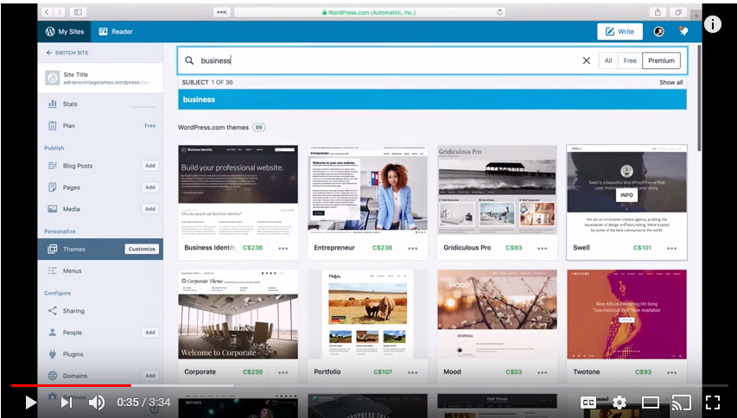

Vs.

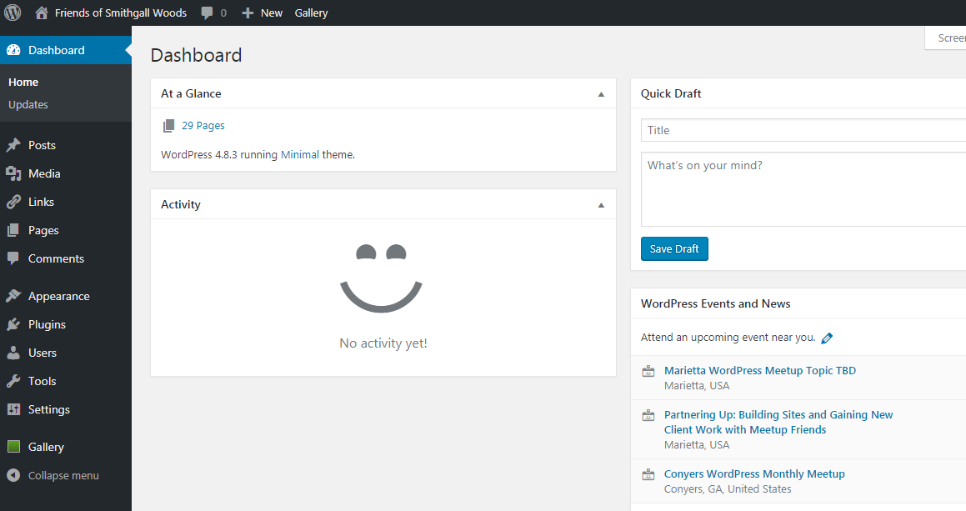

Static customizer:

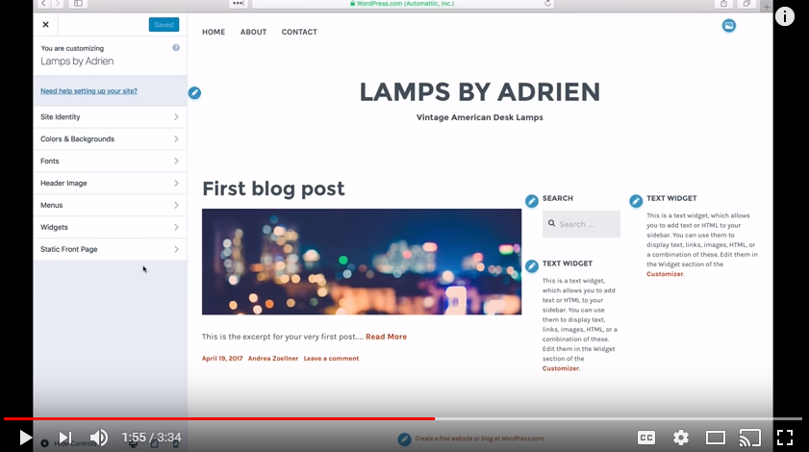

Customizing Menus:

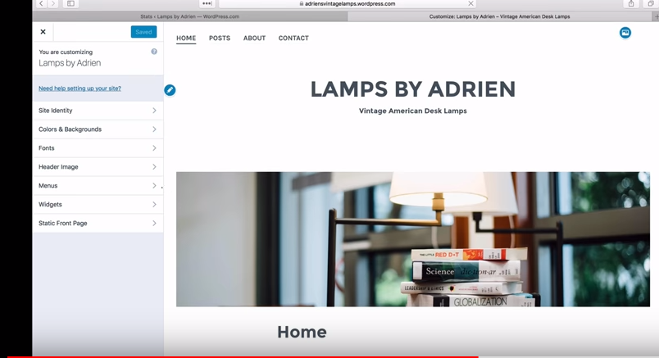

Vs.

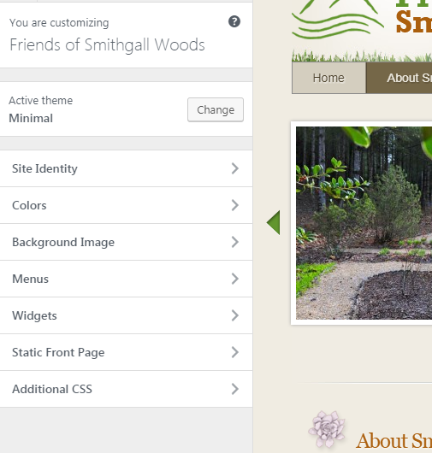

Add a new post:

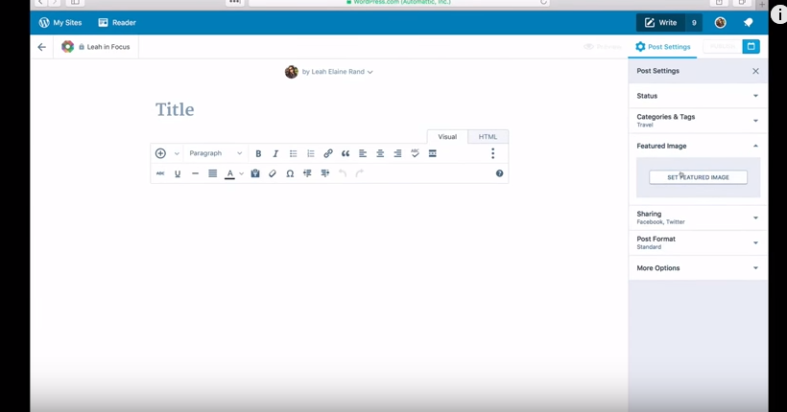

Vs.

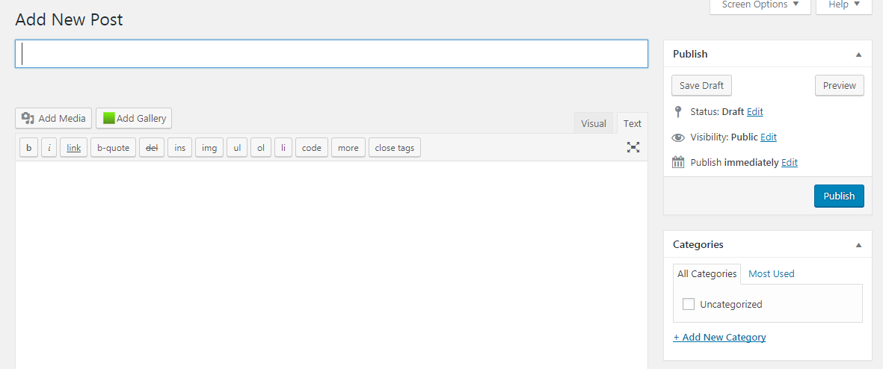

Adding a page:

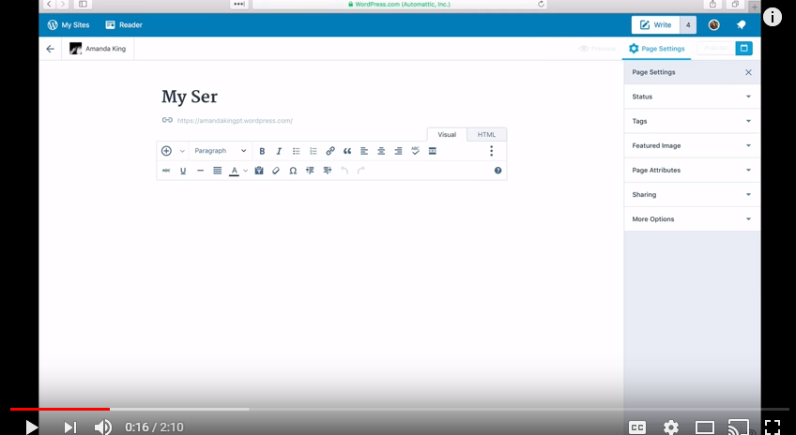

Vs.

